Commonwealth Award Process
The Commonwealth award is open to Guides aged 13 and over, Rangers, Young Leaders and adult members aged 18-25 in all Commonwealth countries.

Member decides she wants to have a go at the Commonwealth Award. It is important that the member understands that she is in charge in developing a personal action plan

The member completes the County Notification of starting Commonwealth Award form.

The form is sent to the Ranger Adviser

The Ranger/Young Leader starts to complete her challenges and is assessed after each challenge

Evidence Required

The member does not have to produce reams of evidence; it could be done in the form of photos, DVD, copies of their plans, or by talking about the event.

The challenge is set by the member herself and she will know (with the help of her Leader(s)) whether she has completed the challenge or not.

Once all the above has been done the member then arranges for the County Commissioner(s) to visit her.

The County Commissioner(s) will be pleased to know that she has completed the Commonwealth Award and will talk to her to find out what she did.

The Leader and member then needs to complete the Finishing Form and send to the Ranger Adviser. The badge and certificate WILL THEN be ordered and plans can be made for the presentation/party within the unit.

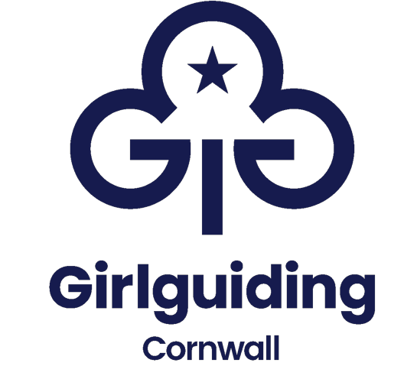

Notification of Starting Commonwealth Award
The Commonwealth Award is for members keen to learn more about the rich history of our organization and to explore countries and cultures unfamiliar to them. The award will help you discover more about your home country and the other 53 states in the Commonwealth. Perhaps you'll learn about the prehistoric roots of Sri Lanka or traditional Māori celebrations in New Zealand. Each challenge is guided by you.

Please complete the form below so that your progress can be monitored and support provided if needed.

Please complete this form and email it to your Ranger Adviser, on rangers@girlguidingcornwall.org.uk

Member's Full Name |  |  | Date of Birth | / /
Commonwealth Award | Start Date  / / |  | Expected Finish Date  / /
Unit
District/Division
Leaders Name
Email
Address
Telephone
Please make a note of other Challenges you are interested in/have started already i.e. Duke of Edinburgh, Queens Guide,

Signature of member: |  | Signature of Parent/Guardian (if under 18)
Signature of Leader |  | Date form completed  / /
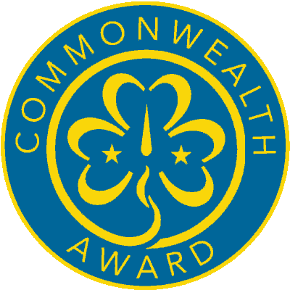
Commonwealth Award
Completion Form

On completion of this form the badge and certificate will automatically be authorized and ordered for you.
Member’s Full Name |  |  | Date of Birth | / /
Address:
Date Completed | Day Month Year
Unit

District & Division

Challenges completed

County Commissioner Visit | Signed: | Date
 | Name:

I certify that ______________(Name of member) has completed the challenges stated above and has met her personal goal to gain the Commonwealth Award. Please forward me the badge and certificate as soon as possible.
Leader Name __________________________________

Leader Signature _______________________________ Date / /

Leaders address to send the badge and certificate to:

Please return this form to: Ranger Adviser rangers@girlguidingcornwall.org.uk

Date Received / / Date Badge Ordered / /

